Exercise 1: Write a Python program to read a file and display its contents

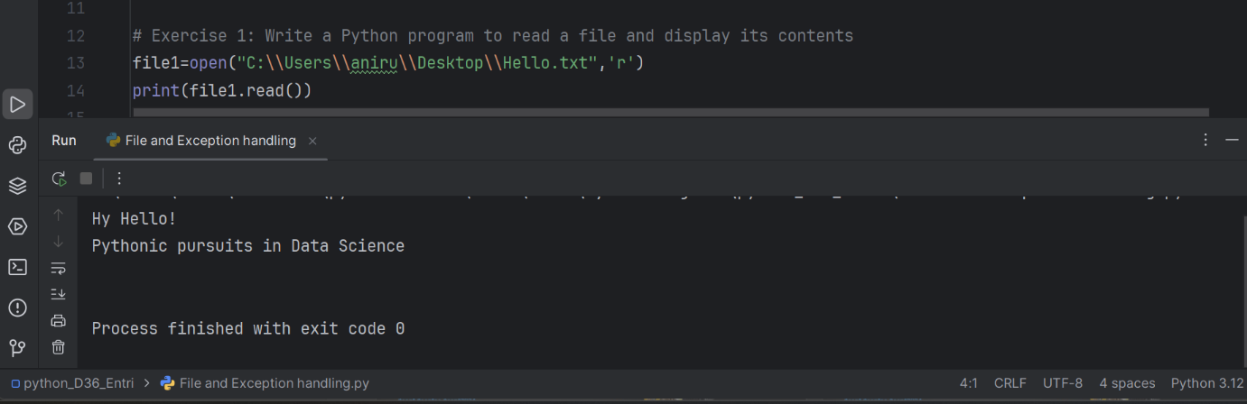

Exercise 2: Write a Python program to copy the contents of one file to another file

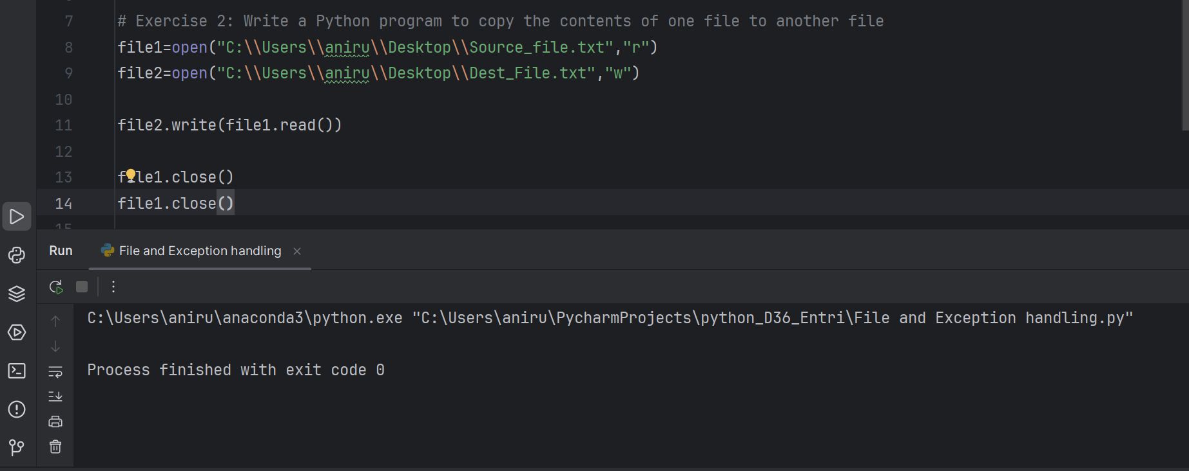

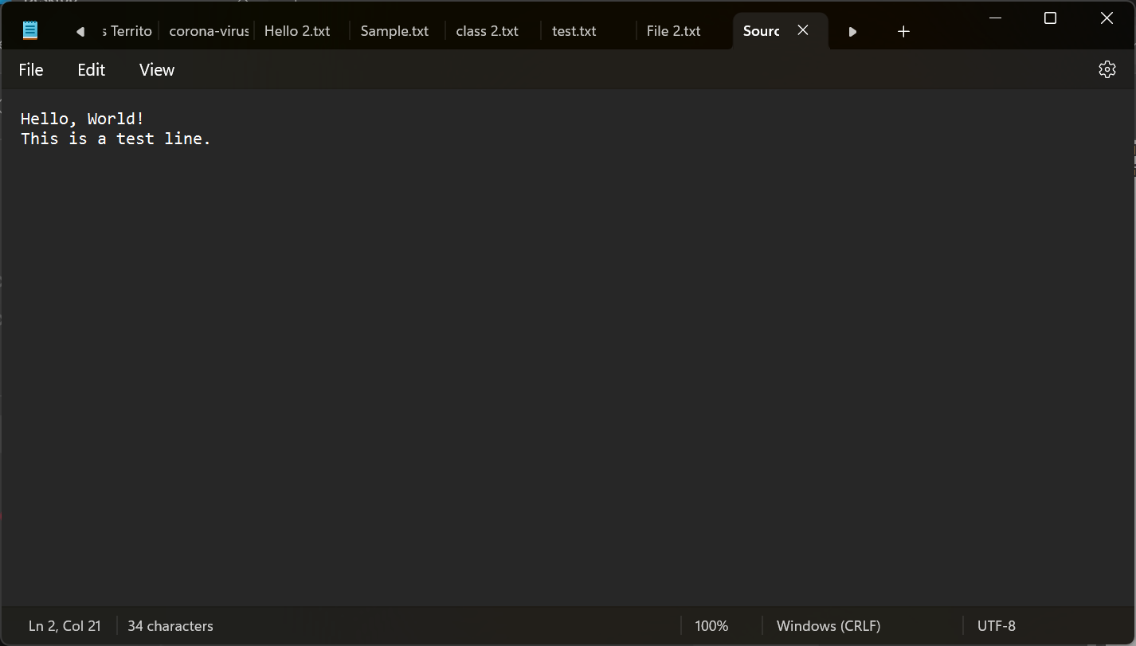

Exercise 3: Write a Python program to read the content of a file and count the total number of words in that file.

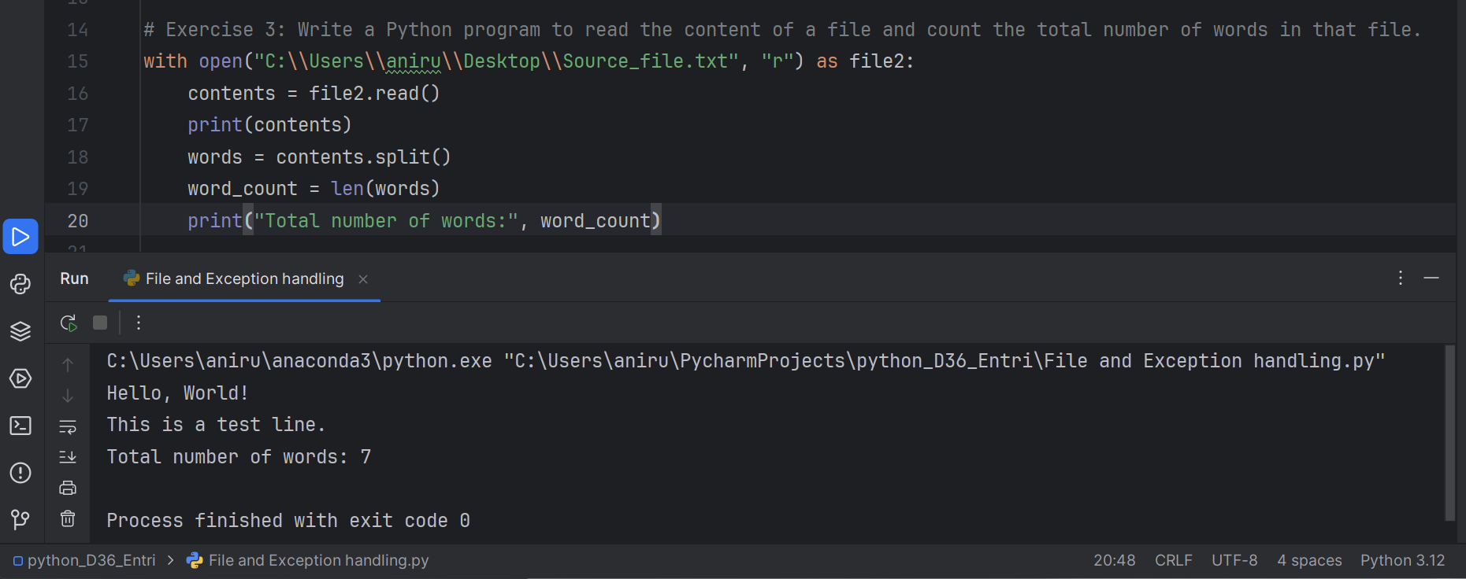

Exercise 4: Write a Python program that prompts the user to input a string and converts it to an integer. Use try-except blocks to handle any exceptions that might occur.

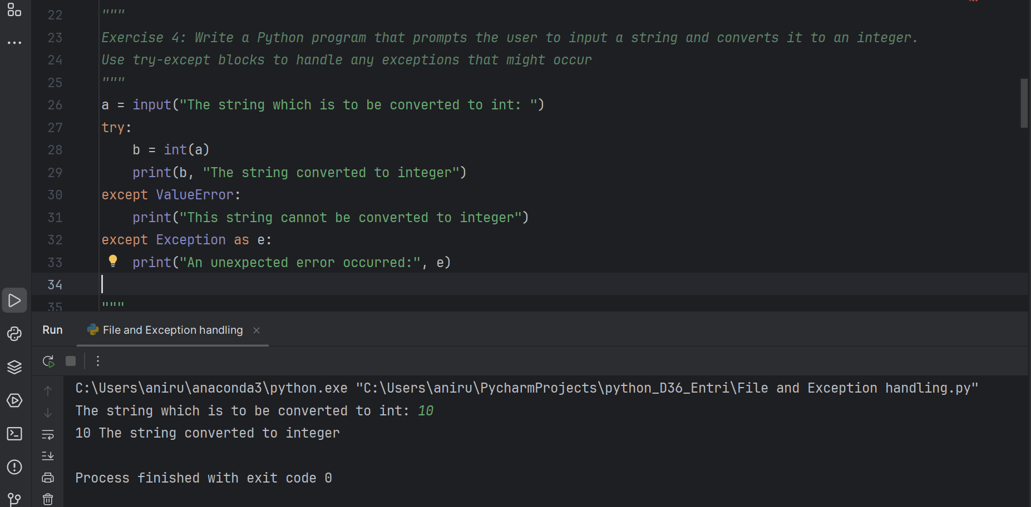

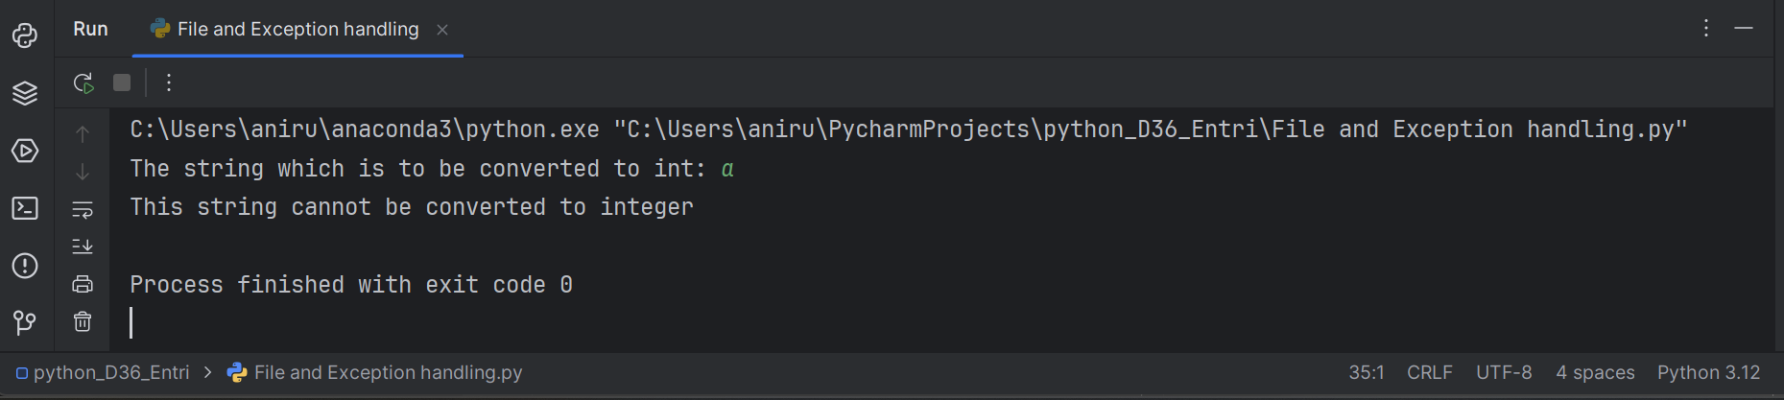

Exercise 5: Write a Python program that prompts the user to input a list of integers and raises an exception if any of the integers in the list are negative.

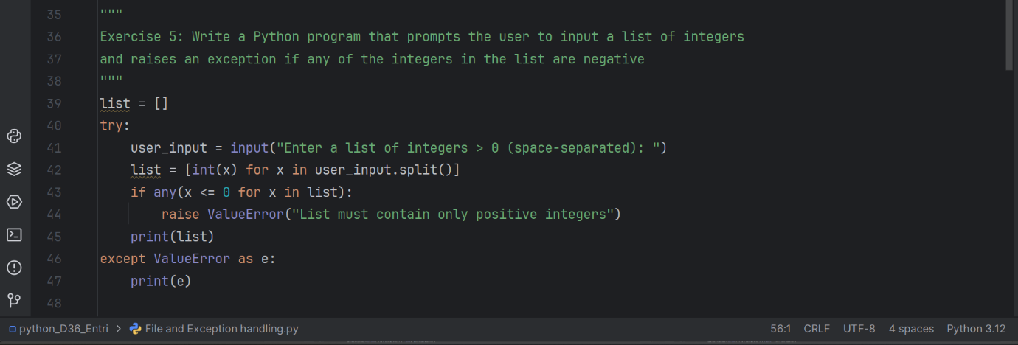

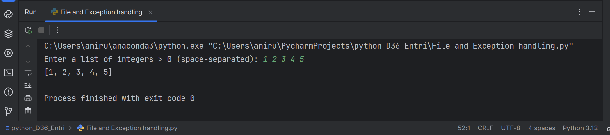

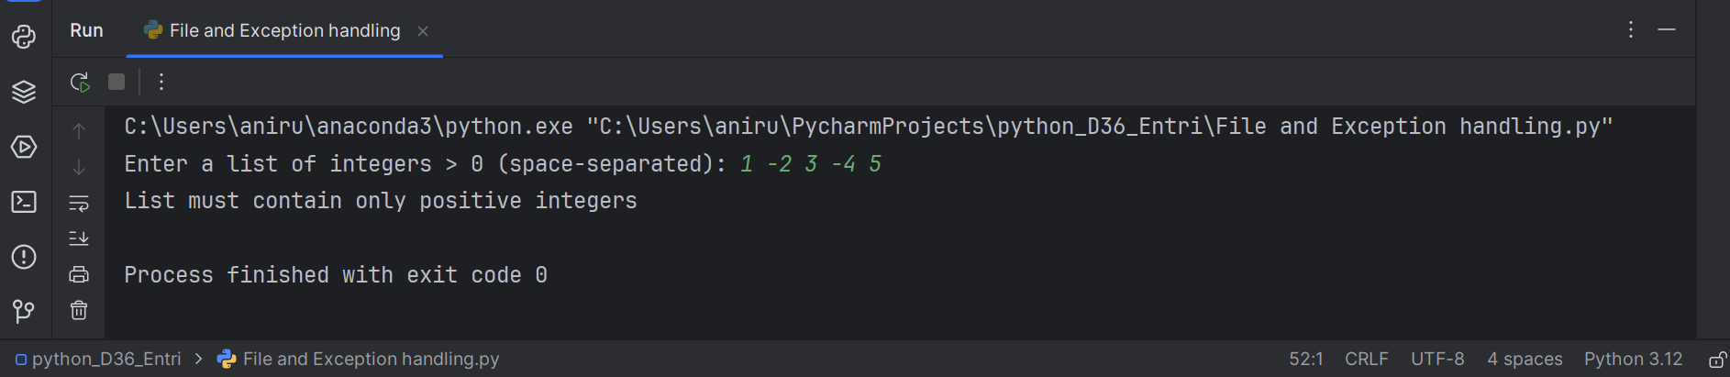

Exercise 6: Write a Python program that prompts the user to input a list of integers and computes the average of those integers. Use try-except blocks to handle any exceptions that might occur. use the finally clause to print a message indicating that the program has finished running.

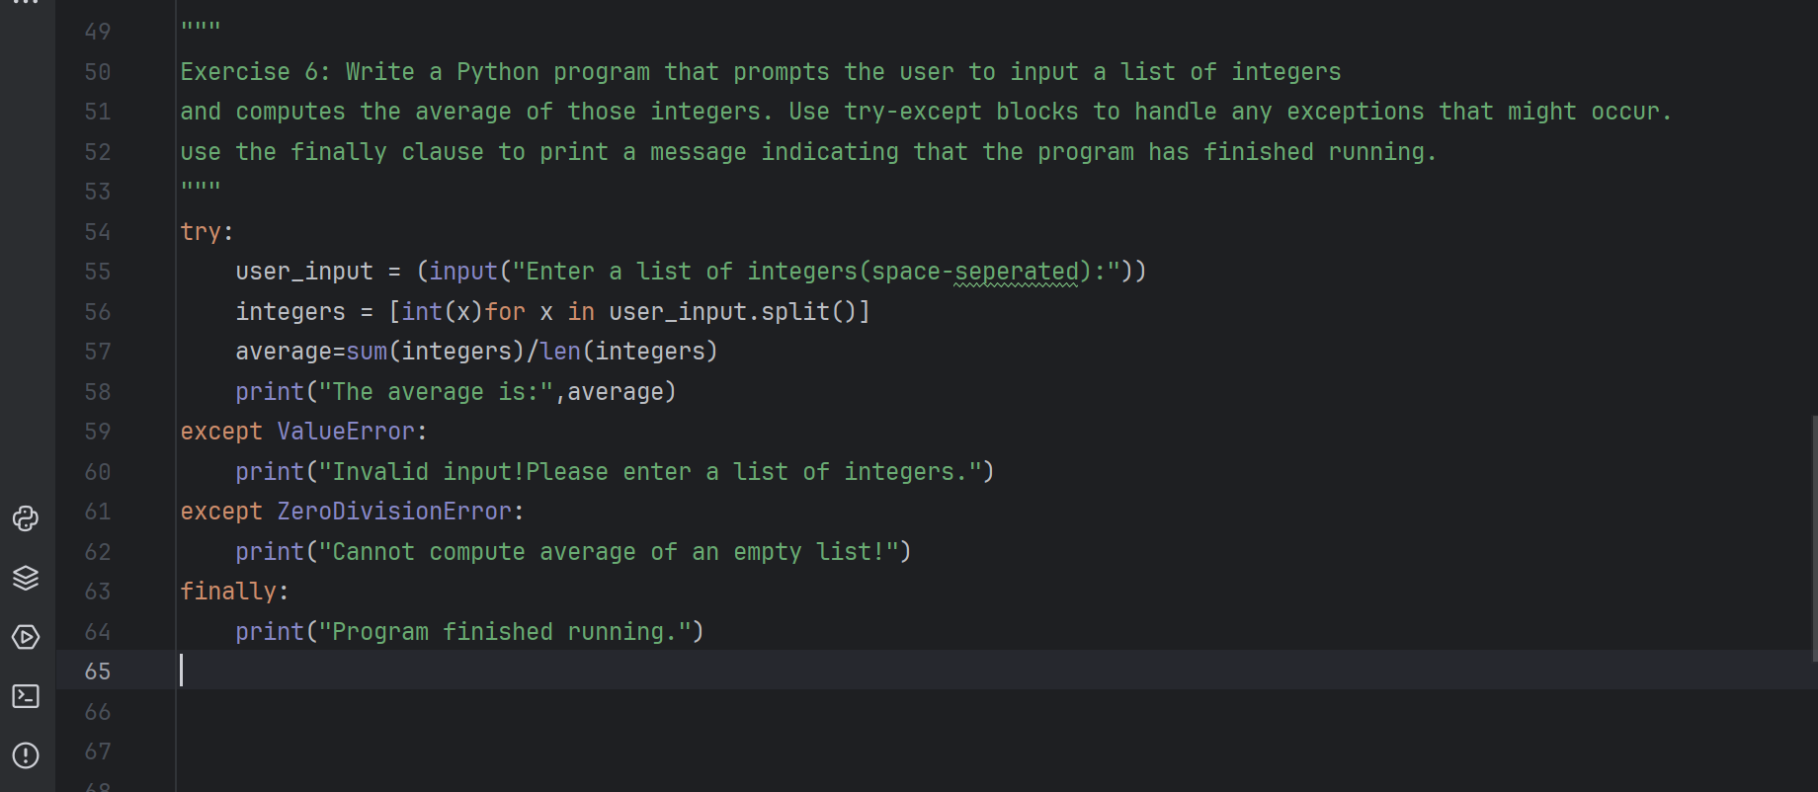

To check with all the possible errors

* Valid Input

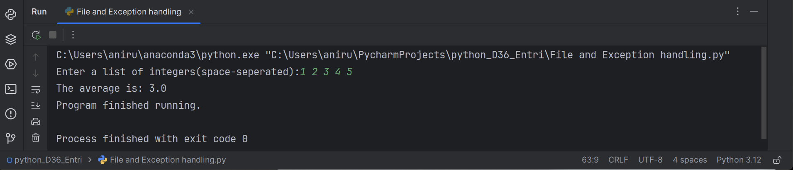

* Invalid Input

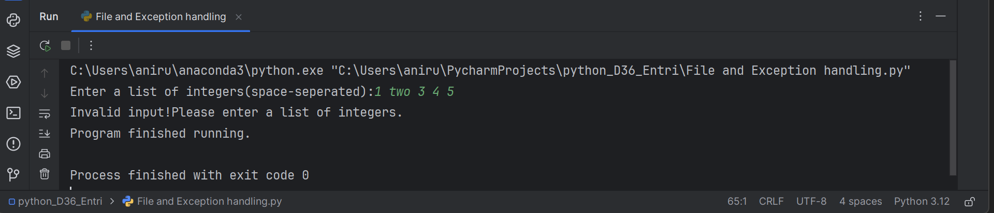

* Empty input

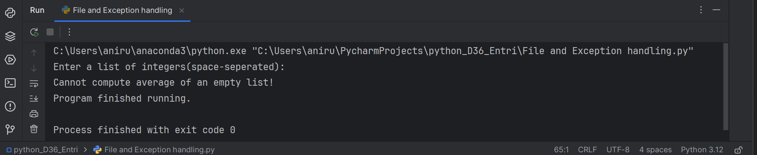

* Input with negative numbers

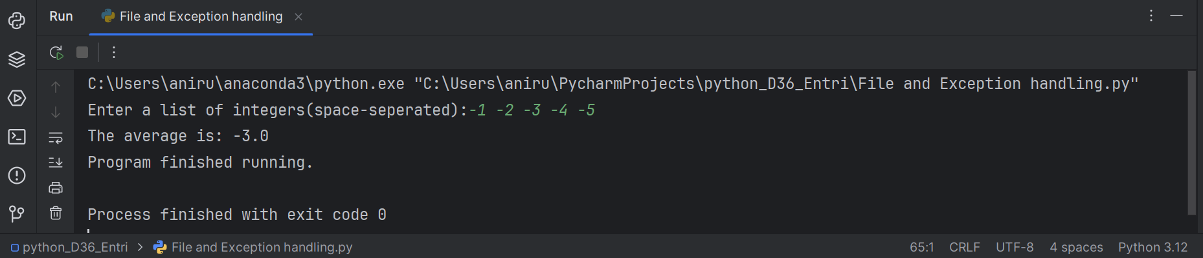

* Input withy Zero

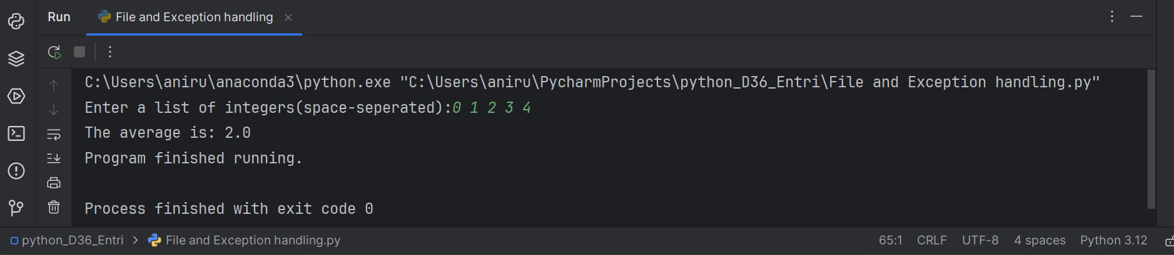

Exercise 7 : Write a Python program that prompts the user to input a filename and writes a string to that file. Use try-except blocks to handle any exceptions that might occur and print a welcome message if there is no exception occurred.

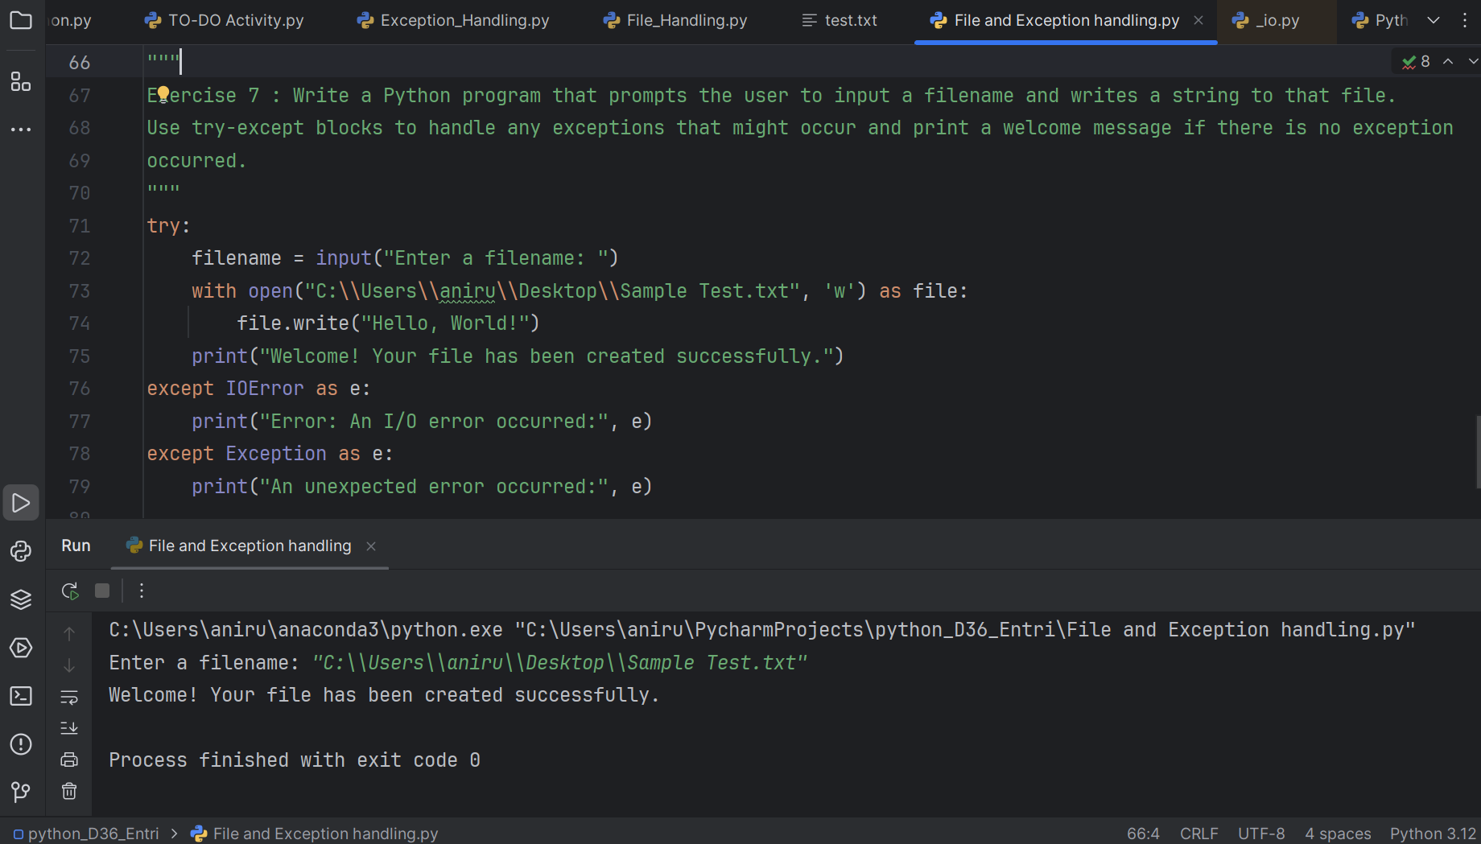

I created a text file named 'Sample Test' and used the above program to add a welcome message to it.

